Practical no.:1
Exercise no.:1.1
Marks1=float(input("Enter marks for subject 1:"))
Marks2=float(input("Enter marks for subject 2:"))
Marks3=float(input("Enter marks for subject 3:"))

Total=Marks1+Marks2+Marks3
Average=Total/3

print("********** STUDENT SCORE CARD**********")

print("Subject1:",Marks1)
print("Subject2:",Marks2)
print("Subject3:",Marks3)
print("Total",Total)
print("Average:",round(Average,2))
Output:-
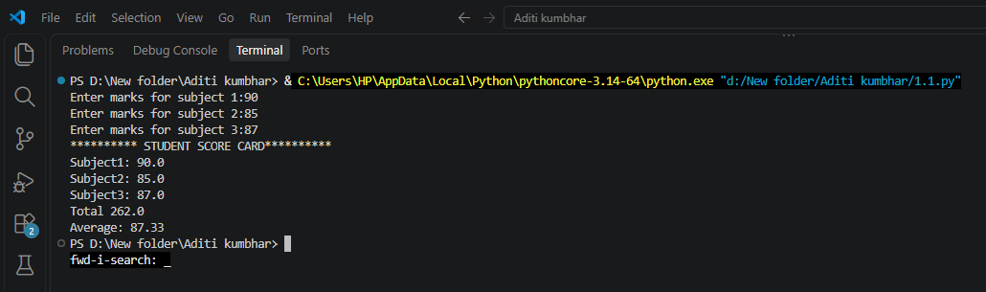

Exercise no.:1.2
Name=input("Enter a Name of Employee:")
Role=input("Enter a Role of Employee:")
Salary=float(input("Enter a Salary of Employee:"))

print("\n==========EMPLOYEE IDENTITY CARD==========")

print("Name:",Name)
print("Role:",Role)
print("Salary:",Salary)
Output:
